**Lab 8 : Write a program to implement multithreading in Java.**

**Theory:**

**Multithreading:** Multithreading is a way of making a computer program do multiple things at the same time. A program can be split into smaller tasks, called **threads**, and each thread can run independently. This means the program can do more than one thing at once, making it faster and more efficient.

For example, in a music player app, one thread could be playing music, while another thread handles adjusting the volume or skipping to the next song. This helps the app to stay responsive without freezing or slowing down.

### **How Does Multithreading Work:** A thread is like a tiny part of a bigger job. When you have multiple threads, each one works on a different part of the task at the same time. This way, the work gets done faster and the computer can use its power more efficiently.

**Source Code:**

public class Hello {

static class MultithreadingDemo extends Thread {

public void run() {

try {

System.out.println("Thread " + Thread.currentThread().getName() + " is running");

} catch (Exception e) {

System.out.println("Exception is caught");

}

}

}

public static void main(String[] args) {

int n = 8;

for (int i = 0; i < n; i++) {

MultithreadingDemo object = new MultithreadingDemo();

object.start();

}

}

}

**Output:**

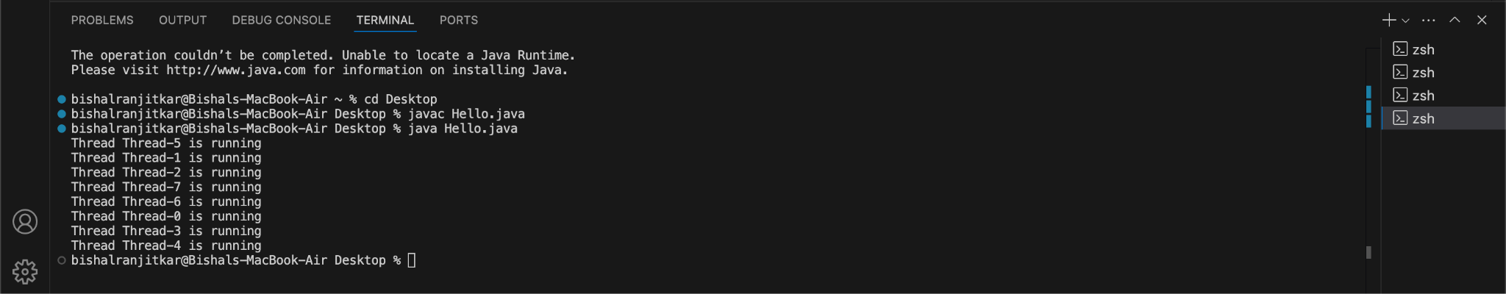

**Conclusion:**

In this lab of Introduction to Cloud Computing, we successfully implemented the concept of

multithreading using Java Programming Language.